Create kind cluster for helm demo:
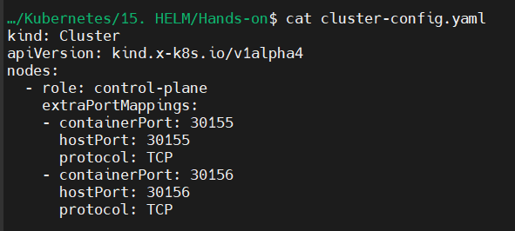
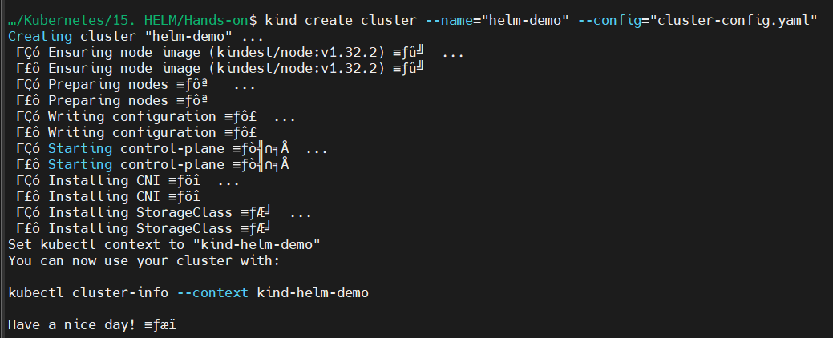
Confirm the context:
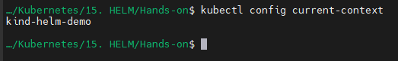
Confirm if helm is installed:
Create your first chart using:
- helm create faraz-first-chart
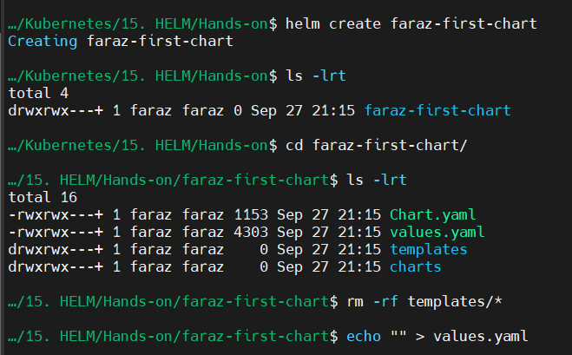
Now we will create our own service and deployment:
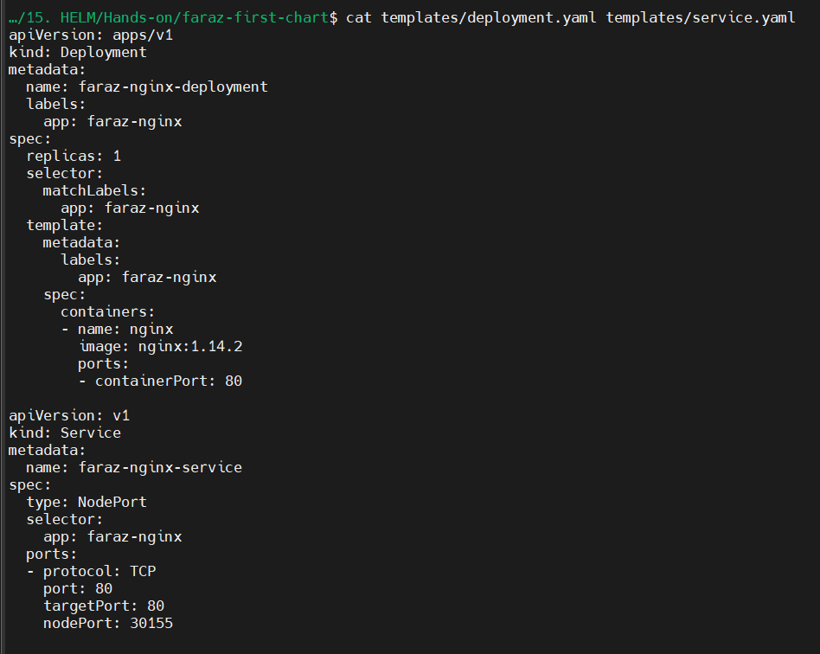

Now that we have our necessary deploy and svc ready, we will release our application:
- helm install faraz-first-release .
- helm list
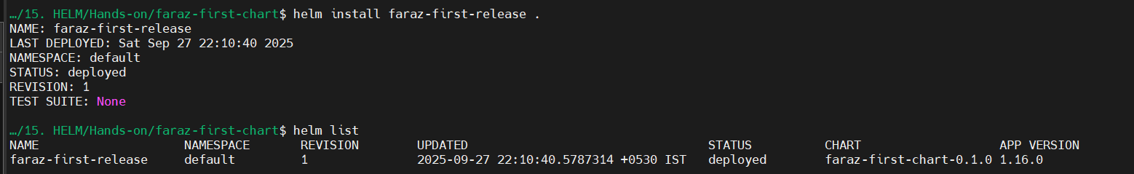
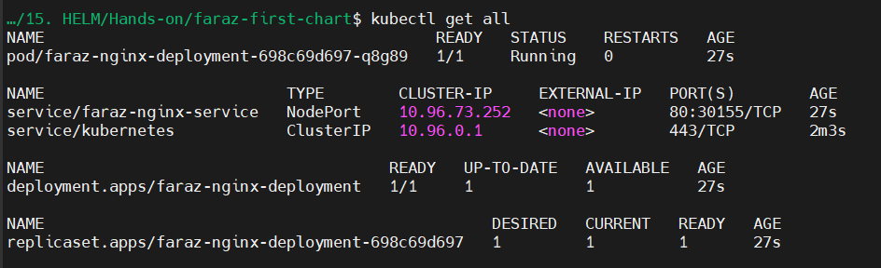

Now we will be able to access the application:
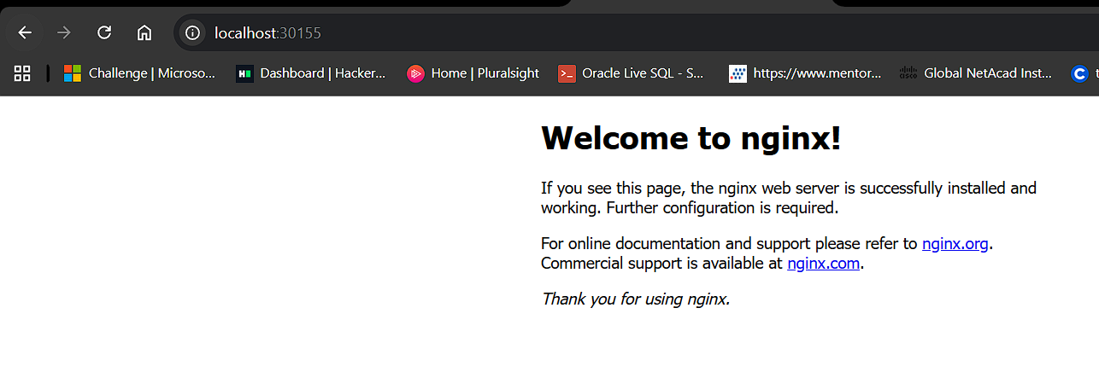

Now, let’s use values.yaml and Helm templating to make your deployment and service configurable and reusable across environments.
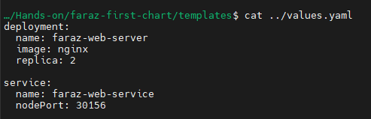

Now let’s edit templates/deployment.yaml templates/service.yaml accordingly:
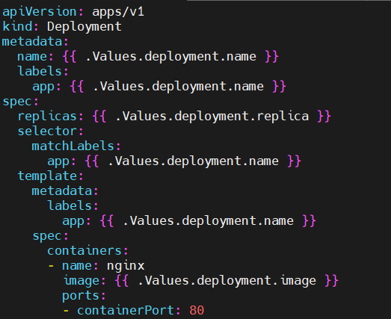
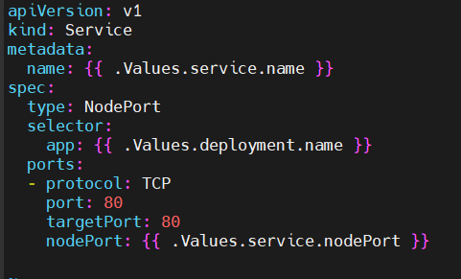

- helm install faraz-web-release .
- helm list
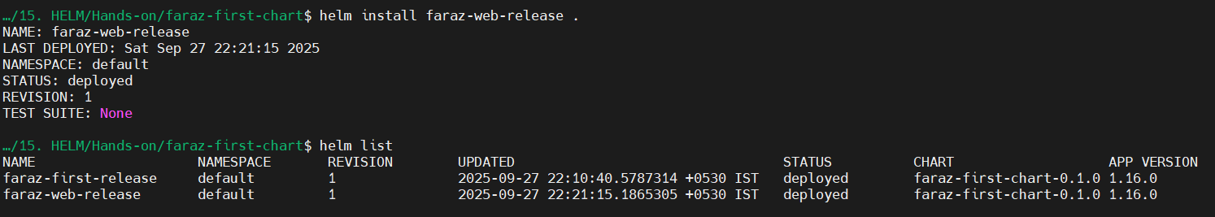
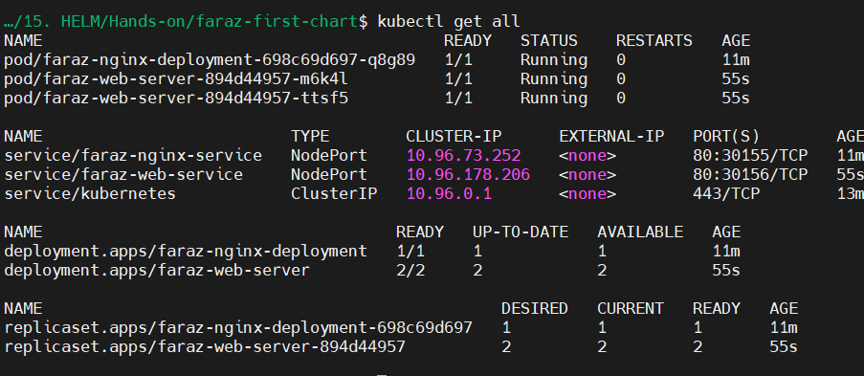
Now you will be able to notice that my application is running on http://localhost:30156/:
